The Victorian Station Master

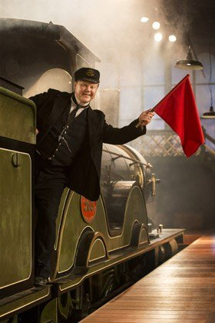

The station master is the person in charge of a railway station.

Historically a male occupation, women were sometimes appointed to the position, and the gender variation station mistress was sometimes employed in such cases.

The station master is responsible for the management of other station employees and holds responsibility for safety and the efficient running of the station. The term was historically employed across stations of all sizes, leading to variation in the precise role. At a major city terminus, with potentially hundreds of employees, the station master's duties would focus on personnel management and public relations. At smaller town and country stations, with a more limited staff, the station master would have far more customer interaction with travelling passengers and would commonly deputise for other members of staff in their absence.

On the contemporary British rail network, a station manager at a major station has duties very similar to those described above. The more localised role of station master at small country stations no longer exists, with group station managers taking responsibility for two or more stations. In very rural areas a station manager may be responsible for a large number of stations, or even for all the stations on a local branch line.

From the late Victorian era onwards, station masters became prominent figures in local communities. Invariably they would be provided with a substantial house and, in rural communities particularly, would have significant social standing.

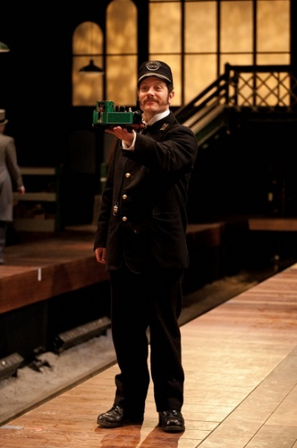What did they wear?

The uniforms worn by station masters, whilst varying widely between different railway companies, often incorporated gold braid embroidery, and peaked caps with gold banding, giving the officeholder a high profile in the community. With his uniform, official housing, and public prominence, the station master was respected and widely attributed with seniority in the local community.

Some station masters achieved legendary fame in their communities. The late James Miller, long-serving station master at Oxford railway station, received widespread recognition for his devoted service in the post, including civic decoration, a public-subscription retirement gift, the award of the British Empire Medal, and the naming of a carriage siding after him.

|  |
| --- |
| Activity ideas:   1. Visit the Essex Records Office and have a look at the fascinating station master logbooks which they have. See if you can spot some of the daily routines which they did. 2. Devise a small role-play scene between the station master speaking to one of the children about his job and what he does and how he feels about it. |