The Chappel Viaduct

**The Chappel Viaduct was built between 1847 and 1848 by over 600 railway workers, called Navvy’s. It was built to allow access across the River Colne and the Colne valley. A viaduct is a bridge which is held up by many arches joined together and is usually used to transport railway across a valley or river.**

The Chappel viaduct was originally going to made using timber or brick piers. But when the designer found brickearth at nearby Mount Bures, it was decided to build it out of bricks. Many of the Navvies who built the Chappel Viaduct were farm workers from East Anglia. They lived in huts on what is now the Chappel Millennium Green while they built the viaduct. It was feared that the navvies would bring trouble to Chappel and Wakes Colne, and those fears continued after the ‘Foundation Stone Theft.’

**The Foundation Stone Theft**

On the 14th of September 1947, the navvies who built the viaduct were present at the ceremony to lay the viaducts foundation stone. A bottle which contained a newly minted sovereign, a half-sovereign, a shilling, a six-pence and a four-penny piece were placed under the stone. Within hours, the money which had been placed under the foundation stone had been stolen.

That evening a bricklayer from Norwich called William Coates paid for a drink at Rose and Crown pub in Chappel with a new looking sovereign. William had been on the platform at the time of the ceremony. He was arrested for the theft, but the case was dismissed due to lack of evidence.

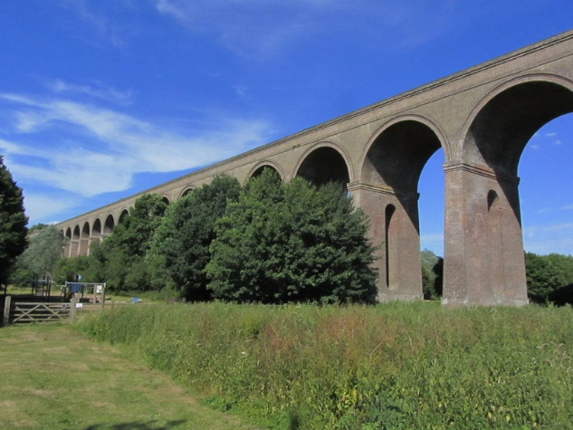

**Did you know?**

-The viaduct is 342 metres (1066 feet) long. That’s the length of 3 ½ football pitches!

-It stands over 24 metres tall (80 feet) That’s almost 6 double decker buses standing on top of one another.