Participant blog:
Visit to the East Anglian Railway Museum
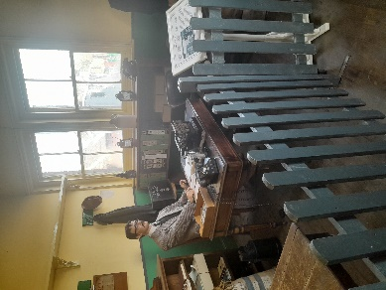
I won’t lie. I was probably looking forward to this part of the project since I was first invited to take part. I always love it how Alfie uses a range of wonderful stimuli to inspire us. Visiting the museum was a great choice. From the very moment you step inside the museum you are taken back in time with the old Victorian ticket office and the waiting room. The museum has a rich history first opening its doors as a railway station during the Victorian era. Despite the rather cold weather, we weren’t disappointed.

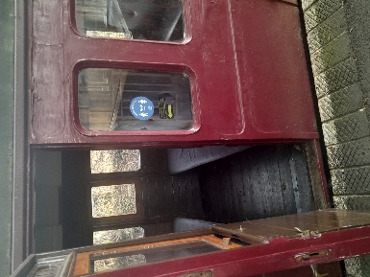
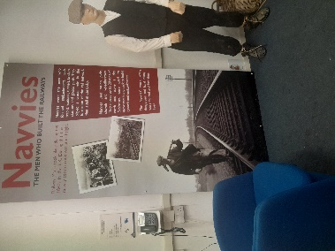
Our tour took us around the museum exploring the steam trains, boarding some of the old carriages, the signal box, the platforms, the Education rooms, model railway, other modes of public transport (including the double decker bus). I particularly liked the shed which had been transformed into a Victorian platform with a steam train as the backdrop. It even had its own ticket office. It gave us a great impression of what it was like during the Victorian times. I loved hearing about the Navvy who were responsible for helping to build the railway, the viaduct and how it was constructed. People’s views on the Navvy and what life was like for them fitting into the local community. Did you know that they picked up and moved up to 20 tons of stone per day! However, they were given a bad reputation locally. We learnt about some of the famous Railway faces including George Stevenson, John Braithwaite, Charles Vignoles and Peter Schuyler Bruff.
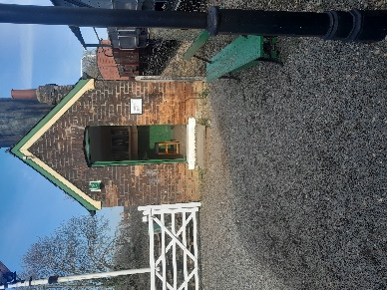
Our highlight for all of us was probably the steam train ride. Sitting on the train, listening to its huffing and puffing whilst smelling the old-fashioned smoke and burning of the coal. It was so peaceful, yet captivating and inspiring at the same time. I couldn’t help but feel a bit emotional and nostalgic.

It was a splendid day and one which I won’t forget. I know that well be back for both more research and our performance.

Gary Wade & Timothy Wood

